**Zonions Application**

* **Technologies:-**

1. **Front-End Technology :-**

**a. React JS**

**2. Back-End Technology :-**

**a . Node JS.**

**b. Express JS.**

**3 . Database :-**

**a. MongoDB.**

* **REST API :-**

**1. Create API for login Admin :-**

<http://localhost:8000/restaurant/login>.

**2. Create API for Get all Restaurant :-**

<http://localhost:8000/restaurant>.

**3. Create API for Get single Restaurant :-**

<http://localhost:8000/restaurant/:id>.

**4. Create API for Get all Restaurant :-**

<http://localhost:8000/restaurant>.

**5. Create API for update Restaurant :-**

<http://localhost:8000/restaurant/:id>.

**6. Create API for delete Restaurant :-**

<http://localhost:8000/restaurant/:id>.

* **Screenshots :-**

**1. Home page :-**

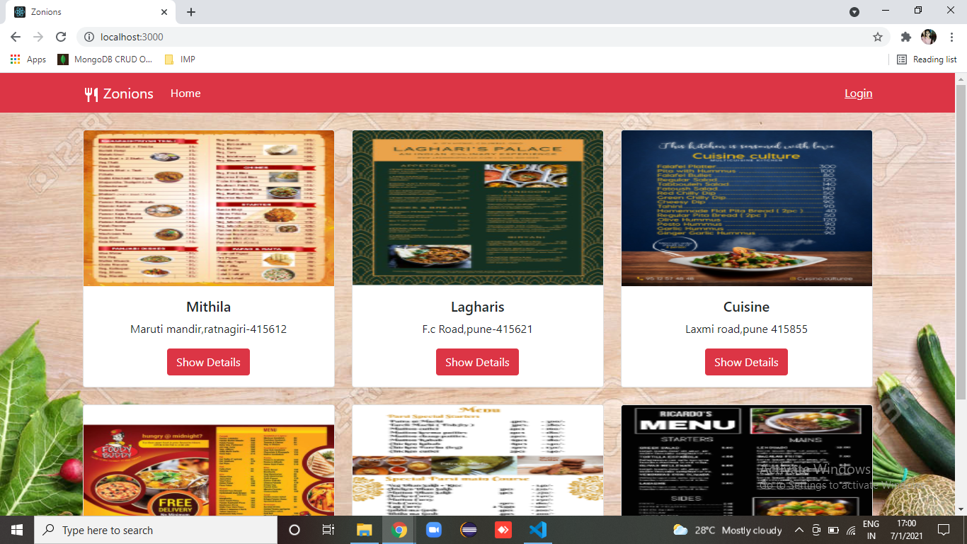

**2. Restaurant details page :-**

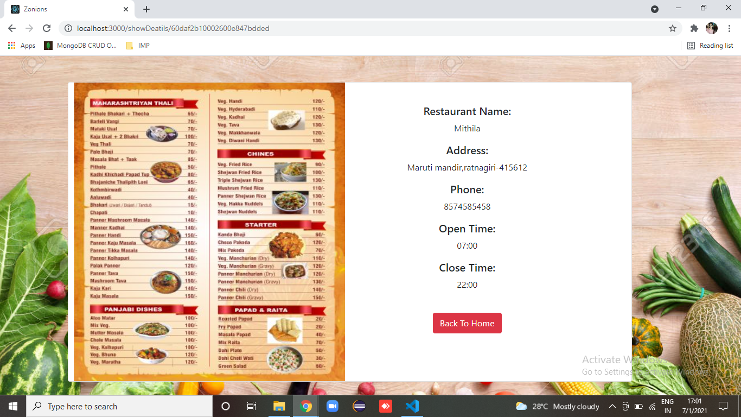

**3. Login page :-**

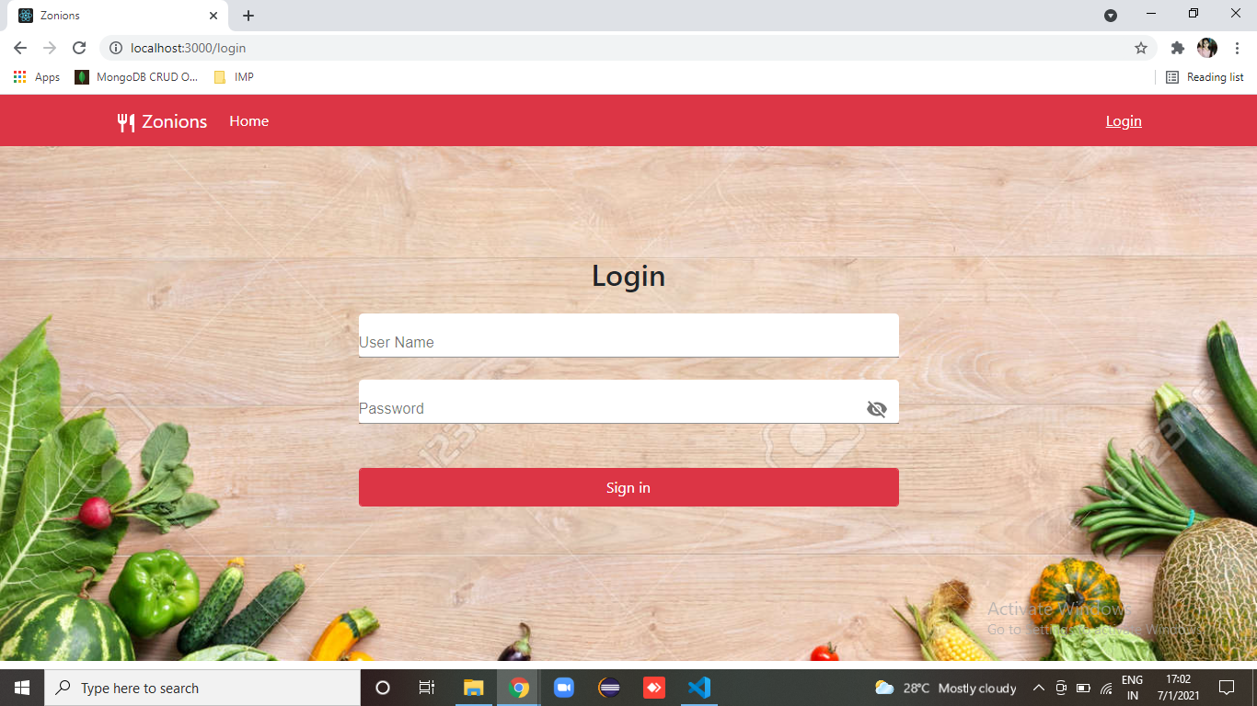

**4. Admin Dashboard :-**

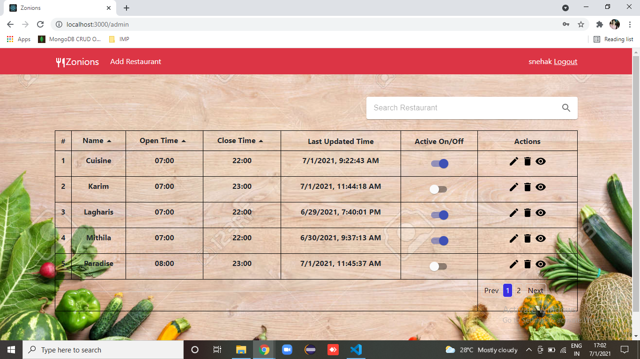

**5. Add Restaurant page :-**

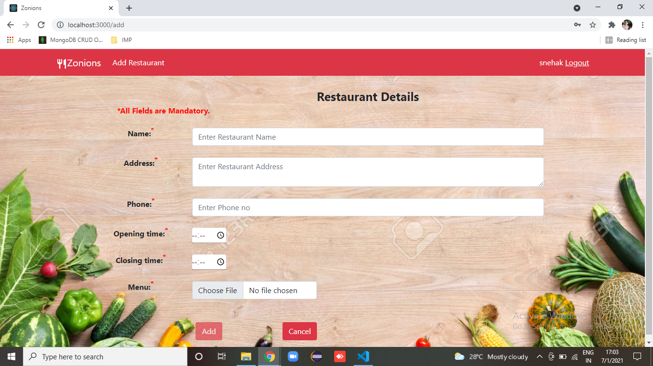

**6. Edit Restaurant page :-**

